**Sample Questions for CA2**

**Q1.**

|  |  |
| --- | --- |
| **Task** | **Details** |
| **Objective** | Create forms in PHP using html tag for user detail store at server side using PHP include method and require.. |
| **Requirements** | Display the form on Browser through the local host. Also apply STRING form validation in the given form. |

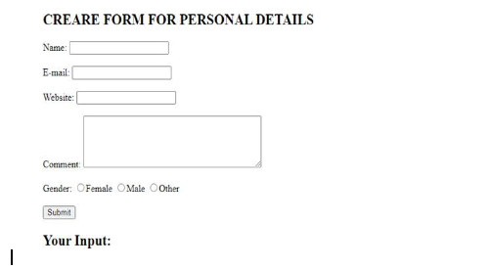

**Q2.**

|  |  |
| --- | --- |
| **Task** | **Details** |
| **Objective** | Create forms in PHP using html tag for user detail store at server side with mandatory fields through GET or POST method in PHP. |
| **Requirements** | Display the form on Browser through the local host. Also apply STRING and EMAIL form validation in the given form. |

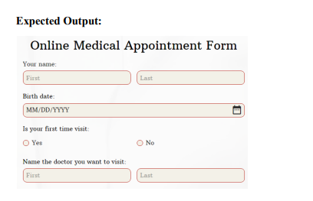

**Q3.**

|  |  |
| --- | --- |
| **Task** | **Details** |
| **Objective** | Create forms in PHP using html tag for user detail store at server side with mandatory fields through GET or POST method in PHP. |
| **Requirements** | Display the form on Browser through the local host. Also apply STRING and EMAIL form validation in the given form. |

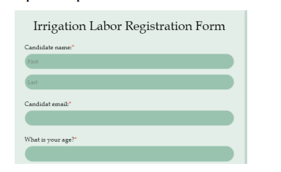

**Q4.**

|  |  |
| --- | --- |
| **Task** | **Details** |
| **Objective** | Create forms in PHP using html tag for user detail store at server side with mandatory fields through GET or POST method in PHP. |
| **Requirements** | Display the form on Browser through the local host. Also apply STRING and EMAIL form validation in the given form. |



**Q5.**

|  |  |
| --- | --- |
| **Task** | **Details** |
| **Objective** | Create forms in PHP using html tag for user detail store at server side with mandatory fields through GET or POST method in PHP. |
| **Requirements** | Display the form on Browser through the local host. Also apply STRING and EMAIL form validation in the given form. |

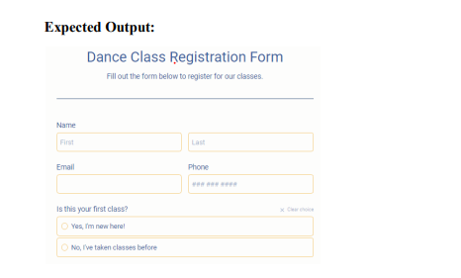

**Q6.**

|  |  |
| --- | --- |
| **Task** | **Details** |
| **Objective** | Create forms in PHP using html tag for user detail store at server side with mandatory fields through GET or POST method in PHP. |
| **Requirements** | Display the form on Browser through the local host. Also apply STRING and EMAIL form validation in the given form. |

**Expected Output:**

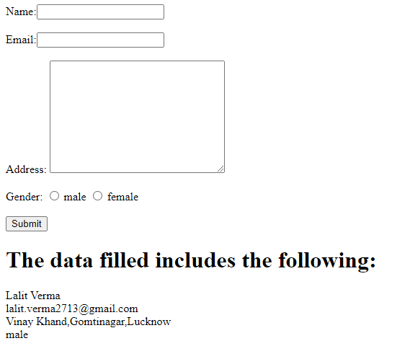

**Q7.**

|  |  |
| --- | --- |
| **Task** | **Details** |
| **Objective** | Create forms in PHP using html tag for user detail store at server side with mandatory fields through GET or POST method in PHP. |
| **Requirements** | Display the form on Browser through the local host. Also apply STRING and EMAIL form validation in the given form. |

**Expected Output:**

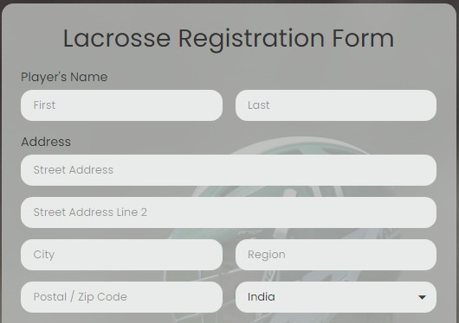

**Q8.**

|  |  |
| --- | --- |
| **Task** | **Details** |
| **Objective** | Create forms in PHP using html tag for user detail store at server side with mandatory fields through GET or POST method in PHP. |
| **Requirements** | Display the form on Browser through the local host. Also apply STRING and EMAIL form validation in the given form. |

**Expected Output:**

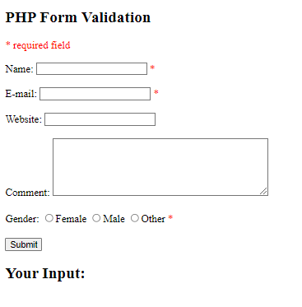

**Q9.**

|  |  |
| --- | --- |
| **Task** | **Details** |
| **Objective** | Create forms in PHP using html tag for uploading file and receiving file at server side with mandatory fields through GET or POST method in PHP. |
| **Requirements** | Display the form on Browser through the local host. Choose the file and message should be display and file upload , it would show in htdocs |

**Expected Output:**







**Q10.**

|  |  |
| --- | --- |
| **Task** | **Details** |
| **Objective** | Create forms in PHP using html tag for user detail store at server side with mandatory fields through GET or POST method in PHP. |
| **Requirements** | Display the form on Browser through the local host. Also apply STRING and EMAIL form validation in the given form. |

**Expected Output:**

